Shipwreck Mystery

Activity Instructions: You are an underwater archaeologist who has identified three new shipwrecks in Lake Michigan (locations on the map on the next page). You took some archaeological information on each of the sites, and now want to try and identify which historical wrecks they are. The only problem is that this area of Lake Michigan has dozens of recorded historical wrecks (just look at all the points on the map!), so you’re going to have to do some work comparing the archaeological information that you collected with primary and secondary sources of known wrecking events. For this activity, ID each of the wrecks by comparing the archaeological data given with the archival information of Lake Michigan wrecks. Keep in mind that there are six possible wrecks included and only three sites. These are all real, identified Lake Michigan shipwrecks, and if you want to learn more you should visit https://www.wisconsinshipwrecks.org/Home#anchor3 which is run by the Wisconsin Historical Society!
Duration: 20-30 minutes
Learning objectives:
- Understand how archaeologists identify sites by comparing archaeological data with primary and secondary sources
- Apply these research methods to identify three shipwrecks
- Learn about the local history of Lake Michigan shipwrecks
Actitivty Terminology:
Depth: How deep in the water the site is located
Beam: refers to the width of a ship or vessel
Mast: An upright post on a sailing vessel used to carry sails
Orientation: The direction the wreck is sitting on the seabed (upright means that the vessel is sitting up on the bottom of the lake)
Vessel type: the boat’s classification. Watercraft are usually organized by their construction, design, and/ or propulsion method. For example, a “steamer” is classified by its propulsion method, while a “steam barge” is classified by its propulsion and hull (body) shape.

Map of 3 Mystery Shipwrecks and other local Wrecks
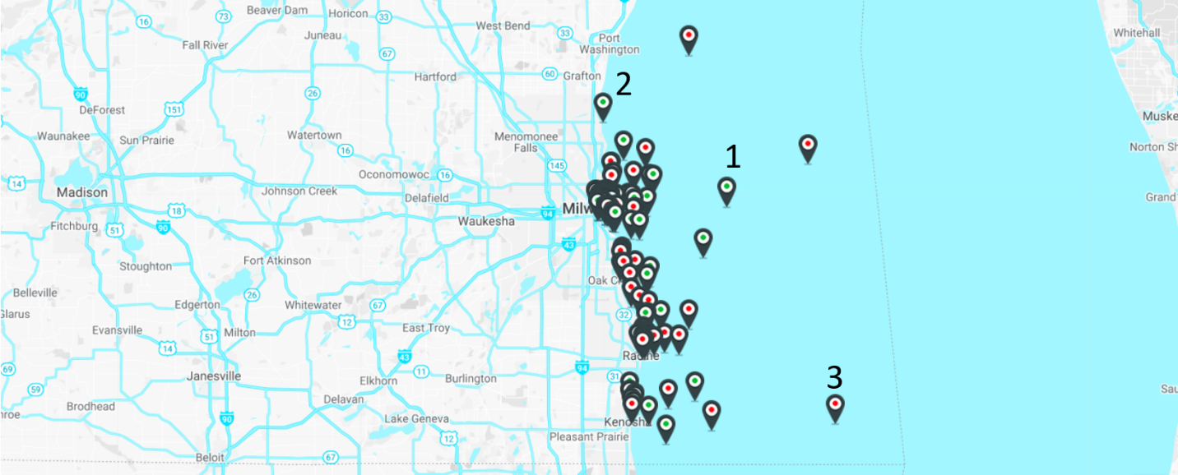

Shipwreck #1
Your ID: __________________________

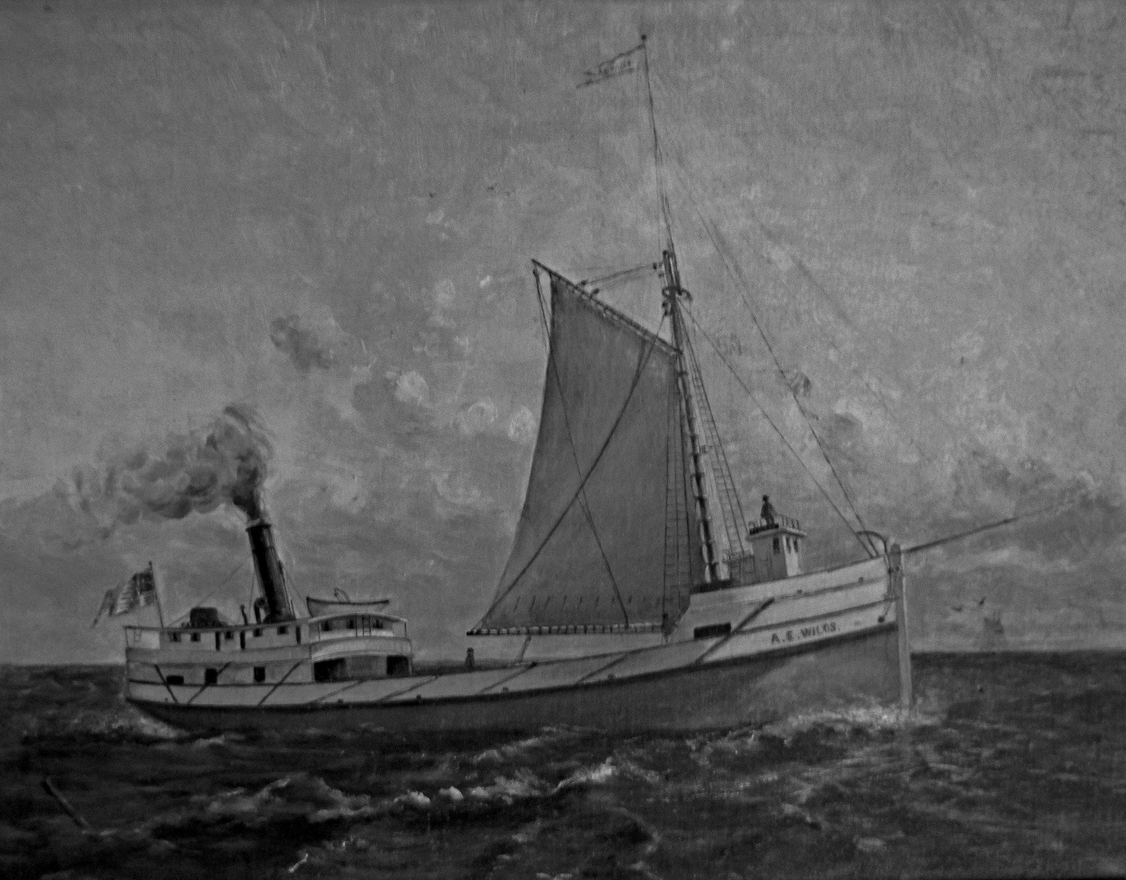
Archaeological Information:
Depth: 260-300 ft.
Orientation: Upright
Length: 136 ft
Beam (width): 28.30 ft
Vessel type: Steamer
Masts: 0

Shipwreck #2
Your ID: ______________________

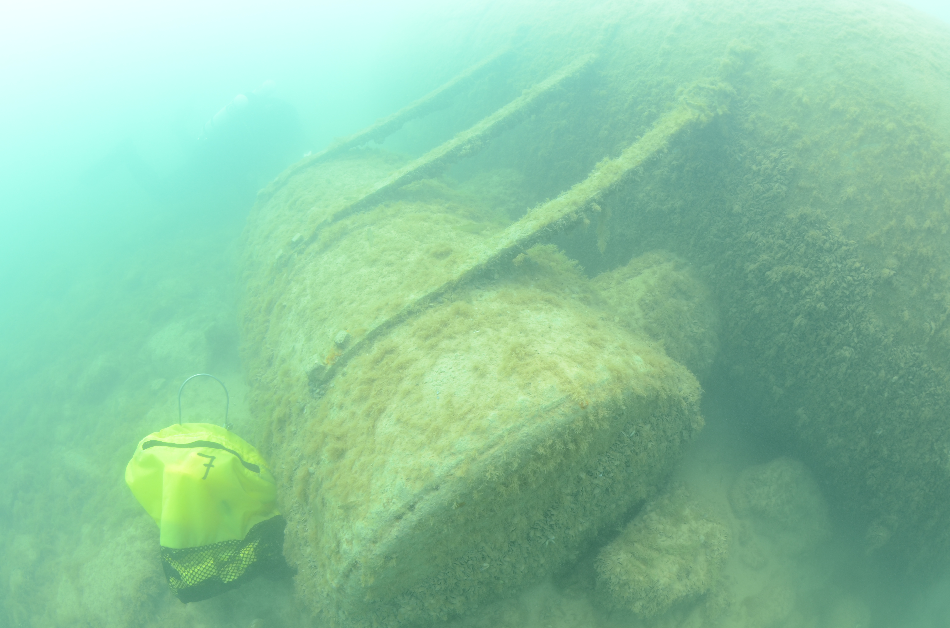
Archaeological Information:
Depth: 15 ft.
Vessel type: steam barge
Length: 104.60 ft
Beam (width): 24 ft.
Masts: 0

Shipwreck #3
Your ID: ______________________

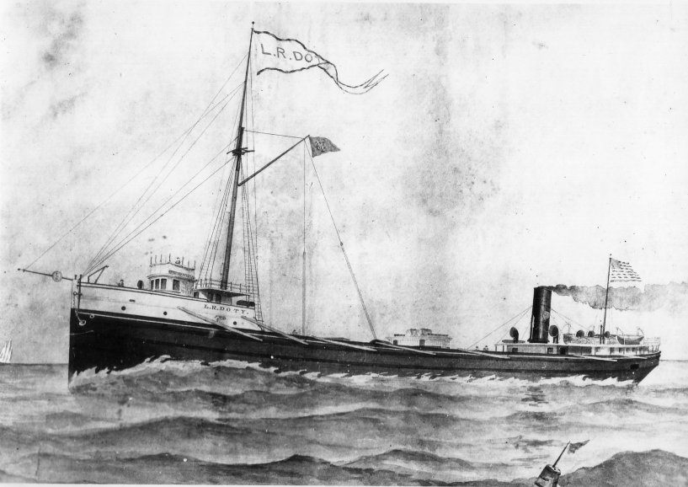
Archaeological Information:
Depth: 320 feet
Vessel Type: steam screw
Length: 291.00 ft
Beam (width): 41.00 ft
Number of Masts: 3

Archival Evidence: Home
Wrecked: 1876
Primary Source: "All attempts to release the scow Home are fruitless, and it now is proposed to strip her to pieces. It is thought when she went ashore she struck the sunken wreck of the Scott, which went down in the same spot ten years ago, and thus stove in her bottom beyond repair." Milwaukee Sentinel 11/17/1876

Secondary Information: The two masted, scow schooner Home wrecked on November 14, 1876, when the vessel’s steering apparatus broke and it ran into a previous wreck. All members of the crew were rescued by the Lafe Saving Service. The wreck is near Racine, WI.

Archival Evidence: L. R. Doty
Wrecked: 1898
Primary Source:
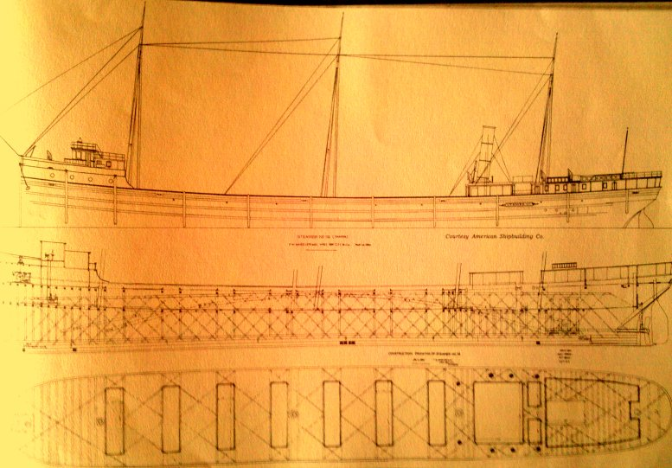
Construction Plan of the L.R. Doty

Secondary Source: The LR Doty was towing the schooner Olive Jeanette from Chicago to Ontario. On October 25, 1898, while both vessels were off the coast of Milwaukee, a storm broke out, with winds of over 70 mph and waves up to 30 ft. The crew of the Jeanette lost sight of the Doty and were not rescued until three days later off the coast of Chicago. The Doty and its 17 man crew were never recovered. 112 years later, the Doty was found in about 320 ft of water, 20 miles SE of Milwaukee.

Archival Evidence: Wisconsin
Wrecked: 1929
Primary Source:
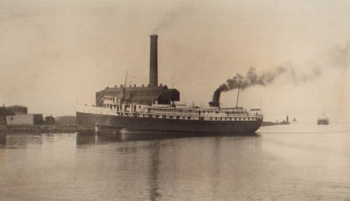
Early 20th c photo of the Wisconsin

Secondary Source: The steamship Wisconsin wrecked south of Milwaukee on October 29 1929 in a northeasterly gale. Eight crew members and the captain perished in the event. The wreck is currently in about 130 feet of water in an upright position on a mud and sand bottom.

Archival Evidence: J.M. Allmendinger

Wrecked: 1895
Primary source: "The steambarge J.M. Allmendinger, which was driven ashore fourteen miles north of Milwaukee late in the season of 1895 and abandoned as a total loss, has at last gone to pieces and her timbers lie scattered along the beach. Not a vestige of the craft remains in sight at the point where she struck. From the time of her abandonment until well along in February the hull and upperworks remained intact and conveyed the idea to some the vessel might be rescued. But the constant beating of heavy seas resulting from the prevailing easterly winds finally disintegrated the hull, and when the collapse came it was of the most complete description, every vestige of the steamer being wiped out in a single night." Door County Advocate 4/24/1897.
Secondary Information: The J.M. Allmendinger ran aground as a result of a gale and blizzard on 11/26/1895 North of Milwaukee. It was en route from to Milwaukee from Sturgeon Bay and wrecked near shore (about 500 ft off shore) at about 3 am in the morning. The captain and eight man crew were rescued by the life saving team.

Archival Evidence: Alice E. Wilds

Wrecked: 1883
Primary Source: "The action of the Milwaukee Steamboat Inspectors in revoking the licenses of Captain Barney Wilds, of the A.E. Wilds and C.B. Coates, of the steamer Douglas was generally approved by marine men. The two boats were in collision off Milwaukee, and the Wilds went to the bottom. The testimony showed that both boats were running at full speed, and although they sighted each other twenty minutes before the crash, neither changed course. Not even a whistle was sounded." Chicago Daily Inter-Ocean, October 19,1892.
Secondary Information: The steamer Alice E. Wilds sank on Sunday, 6/12/1892, after being struck by the passenger steamer Douglas east of Milwaukee while en route from Chicago to Michigan. The Wilds sank very quickly (under 3 minutes), but no lives were lost. The Wilds sank in such deep water (~300 ft) that it could not be recovered.

Archival Evidence: Evra Fuller

Wrecked: 1893
Primary source: "The Fuller broke in two just for'ard of the cabin, which was carried away, and with it went the mizzenmast. Half an hour later the mainmast went with another section of the hull. A few minutes afterward the foremast went by the board, and now not a vestige of the wreck is to be seen from the shore." Door County Advocate 10/21/1893
Secondary Information: The three masted schooner Evra Fuller became stranded on a reef off of Racine during a foggy night in 1893. The life saving crew from Racine saved the entire crew, parts of the vessel, and the crew’s personal items. The wreckage currently lies in ~35 feet of water, about 450 feet east of the Racine Harbor, and is scattered over a wide area.

